The Martand Sun Temple
The Martand sun temple is a Hindu temple located in Mattan, in the Anantnag district of the Kashmir Valley of Jammu and Kashmir, India. It dates back to the eighth century CE and was dedicated to Surya, the solar deity in Hinduism; Surya is also known by the Sanskrit-language synonym Martand (मार्तण्ड, Mārtaṇḍa). The temple was destroyed by Sikandar Shah Miri.
Of all the interesting sights in the vicinity of Anantnag, the ruins of Martand hold the first place and they are easy to access, being just 10 Kms. from the main town Anantnag. It lies on the krewa above Islamabad , and is easily reached from Anantnag.(Islamabad), Bawan and Achabal. The runis of the Hindu temple of Martand or, as it is commonly called, the Pandu-Koru, or the house of the Pandus and Korus—the Cyclopes of the east- are situated on the highest part of a krewa, where it commences to rise to its juncture with the mountains. About 3 miles east of Islamabad, Occupying, undoubtedly, the finest position in Kashmir, this noble ruins is the most striking in size and situation of all the existing remains of Kashmir grandeur. The temple itself is not now more than 40 feet in height, but its solid walls and bold outlines, towering over the fluted pillars of the surrounding colonnade , given it a most imposing appearance.
There are no petty confused details, but all are district and massive, and most admirably suited to the general character of the building. Many vain speculations have been hazarded regarding the date of erection of this temple, and the worship to which it was appropriated , It is usually called the House of the Pandus by the Brahmins , and by the people “Martand”, or the sun, to which the temple was dedicated. The true date of the erection of this temple—the wonder of Kashmir is a disputed point of chronology; but the period of its foundation can be determined within the limits of one century, or between A.D 370 and 500, The mass of building now known by the name of Martand consists of one lofty central edifice, with a small detached wing on each side of the entrance, the whole standing in a large quadrangle surrounded by a colonnade of fluted pillars with intervening , trefoil headed recesses. The length of the outer side of the wall, which is blank, is about 90 yards; that of the front is about 56. There are in all eighty four columns—a singularly appropriate number in a temple of the sun, if as is supposed , the number eighty four is accounted sacred by the Hindus in consequence of its being the multiple of the number of days in the week with the number of signs in the zodiac. The colonnade is recorded in the Rajatarangini as the work of the famous king Laltaditya, who reigned from A.D.693 to 729 . From the same authority we gather though the interruption of the verses is considerably disputed that the temple itself was built by Ranaditya and the side chapels, or at least one of them, by his queen, Amritaprakha . the date of Ranaditya’s reign is involved in some obscurity, but it may safely be conjectured that he died in the first half of the fifth century after Christ. The remains of three gateways opening into the court are now standing. The principal of these fronts due west towards Islamabad. It is also rectangular in its details and built with enormous blocks of limestone, 6 or 8 feet in length, and one of 9, and of proportionate solidity, cemented with an excellent mortar. Fergusson gives the date of Martand as A.D.750, and fixes the reign of Ranaditya as A.D.578-594.
The central building is 63 feet in length by 36 in width,, and alone of all the temples of Kashmir possesses, in addition to the cella or sanctuary, a choir and nave, termed in Sanskrit the antarala and arddhamandapa; the nave is 18 feet square, the sanctuary alone is left entirely bare, the two other compartments being lined with rich panellings and sculptured niches. As the main building is at present entirely uncovered the original form of the roof can only be determined by a reference to other temples and to the general form and character of the various parts of the Maratand temple itself. It has been conjectured that the roof was of pyramidal from, and that the iterance chamber and wings were similarly covered. There would thus have been four distinct pyramids, of which that over the inner chamber must have been the loftiest , the height of its pinnacle above the ground being about 75 feet.
The interior must have been as imposing as the exterior. On ascending the flight of steps, now covered by ruins , the votary of the sun entered a highly decorated chamber, with a doorway on each side covered by a pediment with a trefoil headed niche containing a bust of the Hindu triad, and on the flanks of the main entrance , as well as on those of the side doorways, were pointed ad trefoil niches, each of which held a statue of a Hindu deity. The interior decorations of the roof can only be conjecturally determined, as there do not appear to be nay ornamented stones that that could with certainty be assigned to it. Baron Hugel doubts that Martand ever had a roof, but as the walls of the temple are still standing the numerous heaps of large stones that are scattered about on all sides can only have belonged to the roof.
Cunningham thinks that the erections of this sun temple was suggested by the magnificent sunny prospect which its position commands. It overlooks the finest view in Kashmir, and perhaps in the known world. Beneath it lies the paradise of the east, with its sacred streams and glens, its orchards and green fields , surrounded on all sides by vast snowy mountains, whose lofty peaks seem to smile upon the beautiful valley below. The vast extent of the scene makes it sublime; for this magnificent view of Kashmir is no petty peer in a half mile glen, but the full display of a valley 60 miles in breadth and upwards of 100 miles in length the whole of which lies beneath the “ ken of the wonderful Martand”.
Architecture
The Martand temple was built on top of a plateau from where one can view the whole of the Kashmir Valley. From the ruins and related archaeological findings, it can be said that it was an excellent specimen of Kashmiri architecture, which had blended the Gandharan, Gupta, Chinese and possibly Syrian-Byzantine forms of architecture.
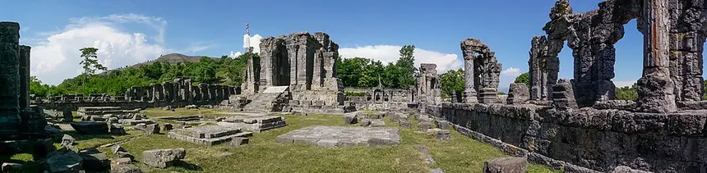
The temple has a colonnaded courtyard, with its primary shrine in its center and surrounded by 84 smaller shrines, stretching 220 feet long and 142 feet broad in total and incorporating a smaller temple that was previously built.The temple turns out to be the largest example of a peristyle in Kashmir and is complex due to its various chambers that are proportional in size and aligned with the overall perimeter of the temple. In Hindu temple architecture, the primary entrance to the temple is situated on the western side of the quadrangle and is the same width as the temple itself, creating grandeur. The entrance is highly reflective of the temple as a whole due to its elaborate decoration and allusion to the deities worshiped inside. The primary shrine is located in a centralised structure (the temple proper) that is thought to have had a pyramidal top - a common feature of the temples in Kashmir. Various wall carvings in the antechamber of the temple proper depict other gods, such as Vishnu, and river goddesses, such as Ganga and Yamuna, in addition to the sun-god Surya.
Its major features included:
- A large rectangular courtyard surrounded by numerous smaller shrines.
- A monumental central temple positioned within the courtyard.
- Tall, imposing stone walls and gateways.
- Elaborately carved architectural elements.
- Large stone slabs used in its construction.
- A commanding location overlooking the surrounding Kashmir Valley.

Destruction
According to Jonaraja (fl. 1430) as well as Hasan Ali, the temple was destroyed by Sikandar Shah Miri (1389-1413) in a zeal to Islamise society under the advice of Sufi preacher Mir Muhammad Hamadani; Jonaraja pinned the blame on his chief-counsel Suhabhatta, a Brahman neo-convert who was held to have manifested a reign of intense persecution for the local Hindus, whereas Ali particularly affirmed Sikandar's convictions in these aspects.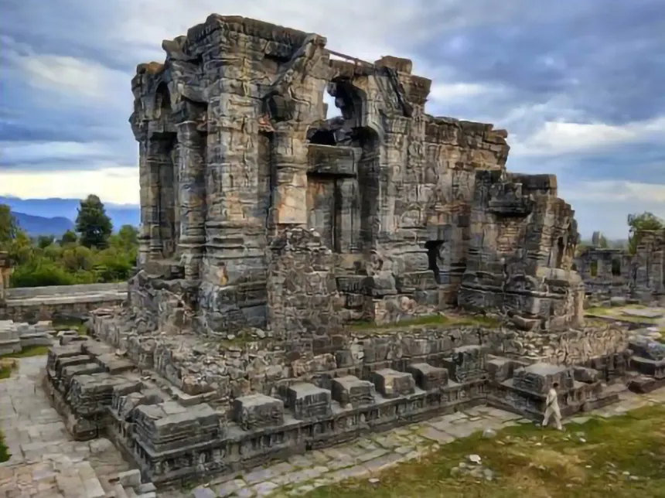
Scholars caution against accepting these sources at face value — Jonaraja was appointed by Sikandar's son, who sought to bring back the Brahminical elite into the royal fold, while later Muslim chroniclers had their motives to fit the past into an idealist tale of orthodox Islamic morality. According to Chitralekha Zutshi and Richard G. Salomon, Sikandar's policies were guided by realpolitikand, like with the previous Hindu rulers, an attempt to secure political legitimacy by asserting state power over Brahmans and gaining access to wealth controlled by Brahminical institutions.J. L. Bhan notes a stone sculpture—a four-armed Brahma, sculpted by the son of a Buddhist Sanghapati and dedicated to Sikandar—to challenge simplistic notions of religious persecution.Slaje disagrees about the absence of religious motivations but notes the aversion of Brahmin chroniclers to be, largely, the result of resistance to the gradual disintegration of caste-hierarchy under Muslim influence.
Geographical and Climatic Features
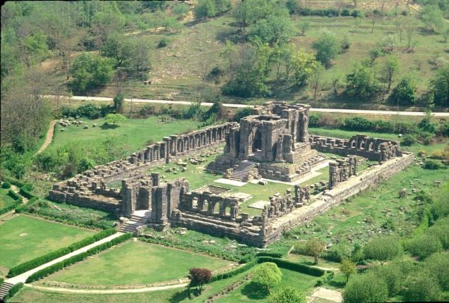

1. Geographical Location
The temple stands in the Kashmir Valley, a large intermontane valley surrounded by the Himalayan mountain systems.
- Location: Near Mattan, Anantnag district, Jammu and Kashmir
- Region: Kashmir Valley
- Approximate elevation: Around 1,700 m above sea level
- Landscape: Elevated plateau/terrace overlooking the valley
- Surroundings: Mountains, agricultural land, settlements and the wider valley landscape
The elevated position gives the temple a strong visual connection with the surrounding natural environment.

2. Kashmir Valley
The Kashmir Valley is geographically distinctive because it is surrounded by high mountain ranges. This creates a relatively enclosed landscape with a broad valley floor and mountainous horizons.
The valley contains:
- Fertile agricultural plains
- Rivers and streams
- Orchards
- Wetlands and lakes
- Mountain slopes
- Forested areas
- Glacial and snow-fed water systems
The Martand temple's position above this landscape would have made it highly visible and provided extensive views in several directions.

3. Topography and Terrain
The temple is situated on slightly elevated and relatively open ground, rather than deep inside a narrow valley or on a steep mountain slope.
This topography was advantageous because it provided:
- A commanding view of the surrounding valley
- A prominent setting for a monumental structure
- Open exposure to sunlight
- Natural separation from the surrounding settlements
- A dramatic architectural backdrop of the Himalayan mountains
The relatively open terrain also helps explain why the temple complex appears particularly impressive when viewed from a distance.

4. Mountain Environment
The surrounding Himalayan mountains strongly influence the geography and climate of the region.
The mountains:
- Affect the movement of weather systems.
- Receive substantial snowfall at higher elevations.
- Feed rivers and streams through snowmelt.
- Create considerable differences in temperature between elevations.
- Form the characteristic mountain-and-valley landscape of Kashmir.
From Martand, the surrounding mountains create a natural frame around the archaeological remains.

5. Soil and Agriculture
The wider Anantnag region contains fertile valley soils, supporting agriculture and horticulture.
Important activities in the surrounding region include:
- Rice cultivation
- Wheat and other field crops
- Apple and other fruit orchards
- Vegetable cultivation
- Saffron cultivation in parts of the wider Kashmir region
The fertile landscape surrounding the monument contrasts strongly with the massive stone architecture of the temple.

1. Four Distinct Seasons
The region experiences four recognizable seasons:
Season | General characteristics
Spring | Cool to mild, increasing rainfall, flowering vegetation
Summer | Pleasant to warm days, relatively comfortable compared with much of India
Autumn | Cool, dry and generally clear; vegetation changes colour
Winter | Cold, with frost and snowfall possible
This strong seasonal variation has influenced both the landscape and the preservation environment of the monument.

2. Summer Climate
Summers are comparatively moderate because of the valley's elevation.
Typical characteristics include:
- Warm but generally not extremely hot conditions
- Longer daylight hours
- Relatively dry and sunny periods
- Occasional rainfall
- Clear views of the surrounding mountains
The elevated location provides a considerably cooler environment than the plains of northern India.

3. Winter Climate
Winter is one of the most significant climatic characteristics of the area.
The region can experience:
- Low temperatures
- Frost
- Snowfall
- Freezing conditions
- Cloudy periods
- Cold winds
Snow and freezing temperatures are particularly important for the preservation of the temple's exposed stone structures.

4. Rainfall
Rainfall in Kashmir does not follow exactly the same pattern as India's main monsoon-dominated regions.
The region receives precipitation from a combination of:
- Western disturbances, particularly important during winter and early spring
- Summer monsoon influence, which reaches Kashmir in a weakened form
- Local convective rainfall during warmer months
Winter precipitation can be particularly important because it may occur as snow at higher elevations.

5. Snow and Freeze–Thaw Weathering
For an ancient stone monument such as Martand, the freeze–thaw cycle is especially important.
reference:https://whc.unesco.org/en/statesparties/in

Destructed and Damaged Parts of the Martand Sun Temple

1. Main Shrine / Central Temple
The central shrine is the most important surviving structure, but it has suffered major damage.
Destroyed or missing:
- The original roof
- Upper portions of the shrine
- Parts of the superstructure
- Much of the original interior arrangement
- The principal image of Surya
The surviving walls and entrance still show the monumental scale of the original shrine. The missing roof is particularly significant because the original temple would have appeared much taller than the present ruins.
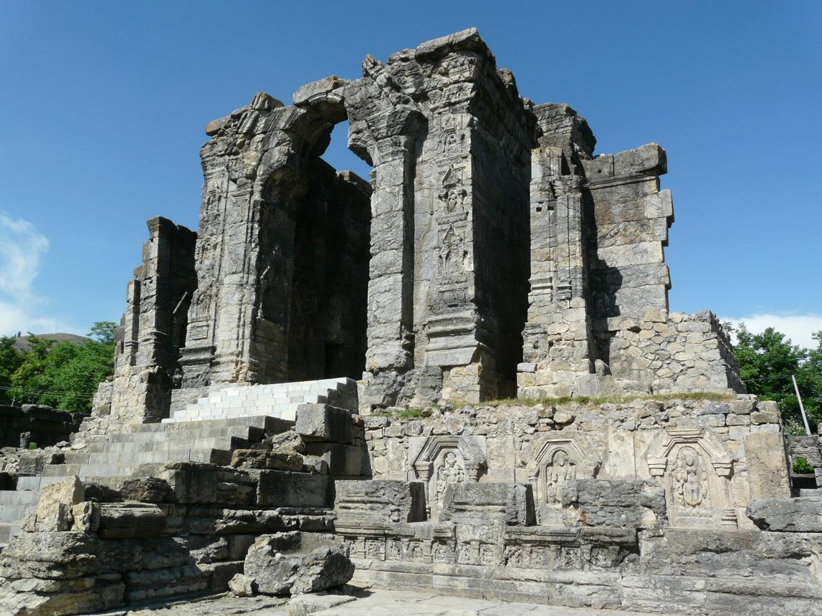

2. Colonnaded Courtyard
The temple originally had a large rectangular courtyard surrounded by a colonnade of approximately 84 pillars and subsidiary shrine spaces. Today, many of these columns are broken, collapsed or survive only as fragments.
The surviving columns show:
- Broken shafts
- Damaged capitals
- Missing connecting elements
- Fallen stone blocks
- Weathered carvings
The remaining colonnade nevertheless gives a clear impression of the original scale of the complex.

3. Entrance Gateway
The main entrance gateway has also been heavily damaged. Large sections of the gateway remain, including massive stone pillars and carved walls, but its original upper structure is incomplete.
The surviving gateway contains:
- Massive stone pillars
- Trefoil-arched openings
- Decorative carvings
- Broken upper masonry
- Missing architectural elements
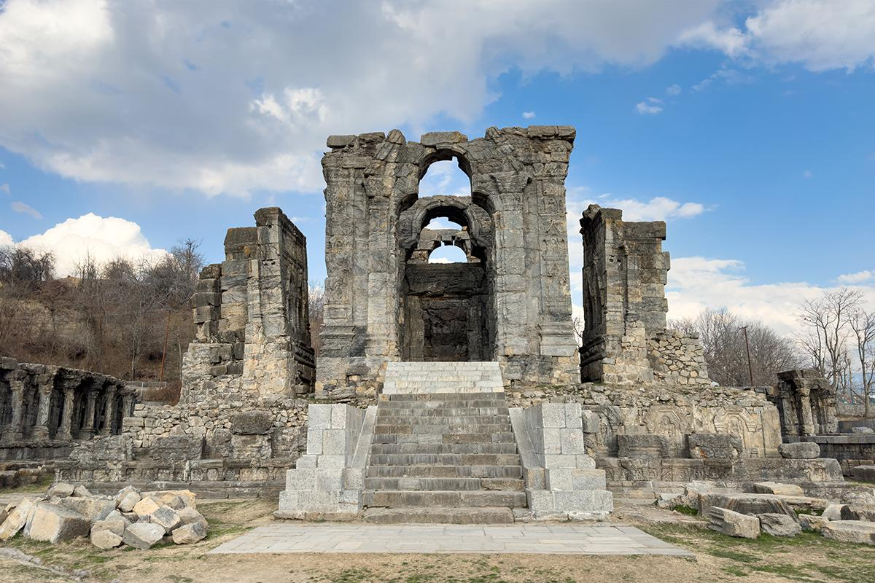

4. Roof and Upper Architectural Elements
One of the most obvious losses is the roofing system.
The present ruins are essentially the lower and middle portions of the original structure. The upper sections, including the main roof/superstructure, have disappeared.
Because of this, the temple today looks much lower and more open than it would have appeared in its original form.

5. Pillars and Arches
Many of the original pillars, arches and connecting stone members have been damaged.
The surviving trefoil arches are particularly important because they are characteristic of Kashmiri temple architecture.
Some arches remain relatively intact, while others have:
- Collapsed
- Lost their upper sections
- Broken into individual blocks
- Been displaced from their original positions

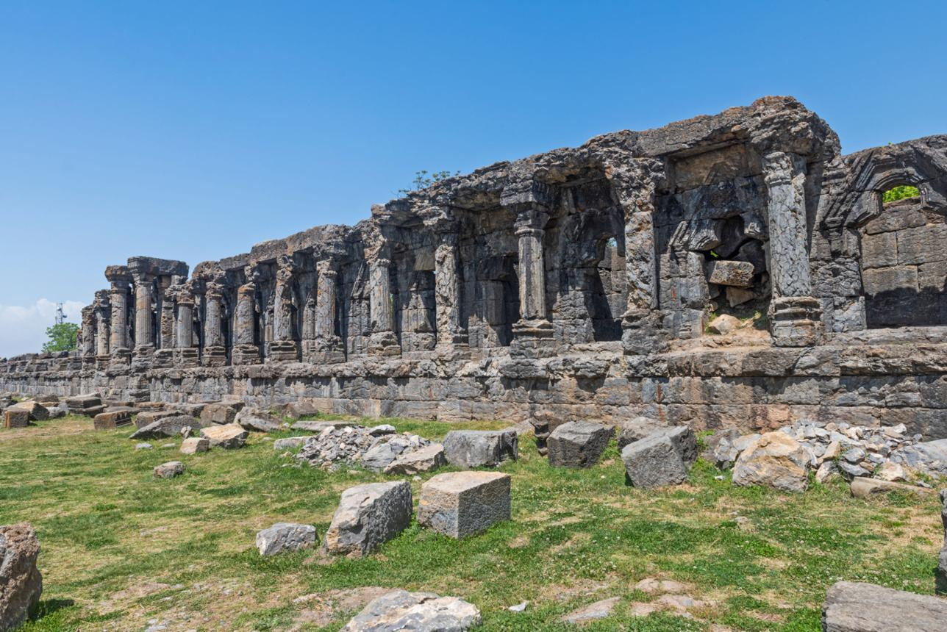

6. Sculptures and Carvings
The temple originally contained numerous sculptures and decorative carvings. Many were damaged, disfigured or removed.
Surviving fragments include representations of:
- Hindu deities
- Surya
- River goddesses
- Mythological figures
- Decorative motifs
Some surviving sculptures have visibly damaged faces and other broken portions.

7. Subsidiary Shrines
The large courtyard was surrounded by numerous smaller shrine spaces. Many of these are now collapsed or reduced to foundations and partial walls.
Only portions of their original masonry survive, making it difficult to reconstruct every individual shrine with certainty.

8. Pradakshina / Passage Areas
The passageways around the central shrine have also suffered considerable damage. Some columns and walls remain, while other sections have collapsed.
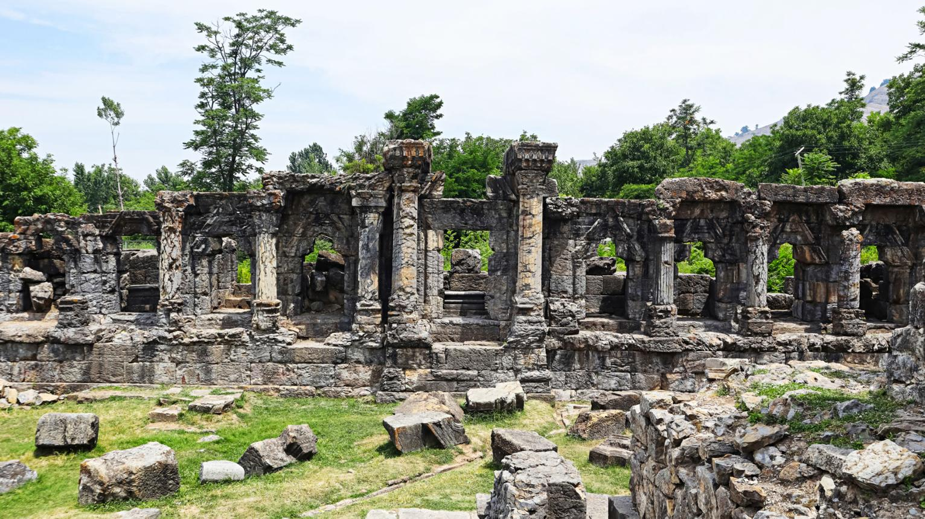
reference:https://indianexpress.com/article/explained/explained-culture/martand-temple-kashmir-history-controversies-explained-8129852

Source - https://www.incredibleindia.gov.in/en/jammu-and-kashmir/anantnag/martand-sun-temple
A timeless marvel carved out of black stone
The Martand Sun Temple is an ancient Hindu temple situated amidst the stunning scenery of Jammu and Kashmir. The Martand Sun Temple is a medieval-period Hindu shrine near Anantnag. Built during the 8th century AD, this architectural marvel is dedicated to Surya, Hinduism’s greatest solar deity; Surya is also called Martand in the Sanskrit language, hence the name. You will marvel at its exquisite blend of Gandharan, Gupta, Greek, Roman, Syrian-Byzantine and Chinese architectural styles, all of which seem integrated in this enchanting structure. Even though it is currently abandoned due to deterioration, it exudes nostalgia while inviting visitors to witness its timeless beauty.

Conceived and funded by Lalitaditya Muktapida, ruler of the Karkota Dynasty, the Martand Sun Temple stands as an ancient architectural marvel. Constructed from intricately carved black stone, the temple exudes a unique grandiosity that captures the brilliance of early medieval Indian architecture. The choice of black stone adds a robust and enduring quality to the structure and enhances its majestic presence against the backdrop of the soft landscape surrounding it. This stark material contrast highlights the temple's structural details and artistic embellishments.

The temple's highlight is its expansive courtyard that comprises of a central shrine surrounded by a complex of colonnades and 84 smaller shrines, covering a length of 220 feet and breadth of 142 feet, and incorporating a smaller temple that was previously built, thus creating an unforgettable architectural ensemble which once echoed with the footsteps of pilgrims and the chants of ancient rituals. Although now in ruins, the remnants of the temple stand as a proud silhouette against the horizon, offering visitors a glimpse into its past splendour. The large-scale edifice and its elaborate decorations testify to the artistic mastery and spiritual depth of its creators. The Martand Sun Temple is distinguished as a site of national importance, as designated by the Archaeological Survey of India (ASI). This architectural marvel stands as a testament to ancient craftsmanship and spiritual heritage, drawing visitors from across the globe to marvel at its timeless beauty and historical significance.

A site of complex narratives, spiritual, historical, and contemporary
Stone sculptures within the complex, such as the four-armed Brahma, help reveal more complex historical narratives, while holding great religious significance for Kashmiri Pandits who rank this temple among their three holiest pilgrimage destinations. It is a testament to Kashmiri Hindu architecture's unparalleled artistic prowess and creative brilliance.
The temple has also been featured as the backdrop in Hindi-language films such as 'Haider', 'Man Ki Aankhen' and 'Aandhi'.
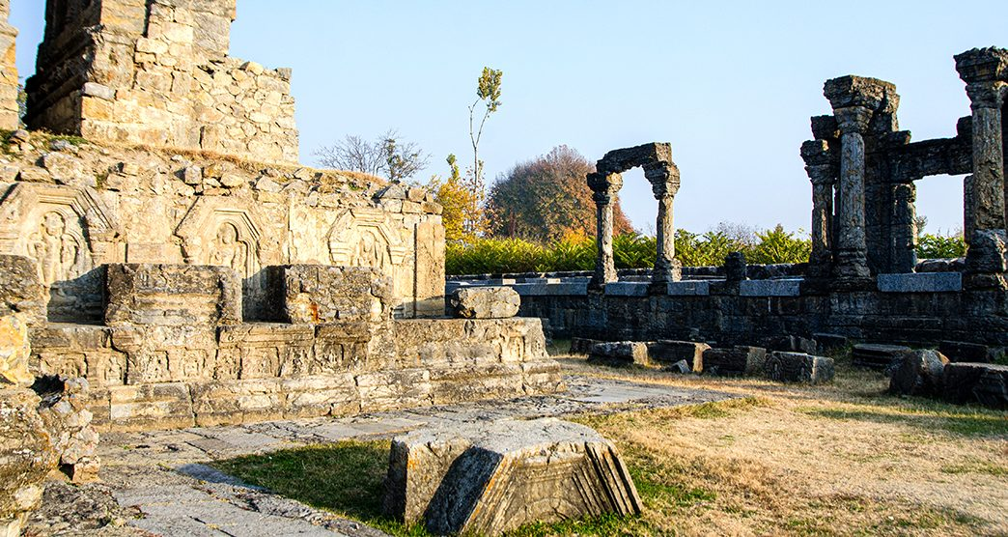
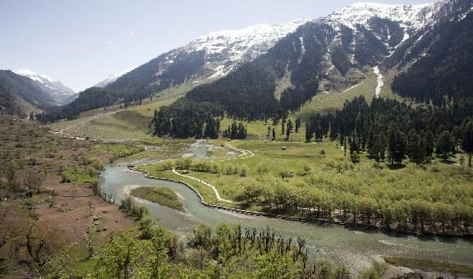

Experience
Thrilling Adventures In and Around Anantnag, Kashmir

Discover stunning views beyond
The temple offers captivating ruins and intricate carvings to delight you. From its plateau location, you can enjoy incredible panoramic views of Kashmir Valley. Spend some time wandering around nearby markets selling exquisite local handicrafts and souvenirs to returni home with unforgettable memories!
Enjoy the festive celebrations of the Kashmiri Spring Festival held annually in its surrounding regions. Engage in cultural events showcasing Jammu and Kashmir's rich artistic traditions and folk performances.

How to Reach
By Air
The nearest airport is Srinagar International Airport (SXR), located about 50 kilometers from Anantnag.
From Srinagar Airport, you can hire a taxi or take a shared cab to reach Anantnag.
By Train
The nearest railway station is Jammu Tawi Railway Station (JAT).
From Jammu Tawi, you can hire a taxi or take a bus to reach Anantnag. The journey can take around 6-8 hours depending on traffic and road conditions.
By Road
Anantnag is well-connected by road to major cities in Jammu and Kashmir and other parts of India.
You can take a direct bus or hire a taxi to reach Anantnag from Srinagar, Jammu, or other nearby cities.

Martand Sun Temple: An exposition of the
Architectural Features
Shahid Qadoos Lone and Prof. M.C. Shrivastava
Research Scholar Dept. Of AIHC & Archeology APS University Rewa M.P.
Professor and Head, Dept. Of AIHC & Archeology APS University Rewa M.P.
Abstract:
Martanda Sun Temple, located in the Anantnag district of Jammu and Kashmir, is one of the few sun temples in
India. Though the temple is in ruins, it retains its grandeur and majesty. There are numerous versions of the
temple's history, ranging from mythological legends to literary traditions of recorded history. This paper
attempts to understand Martanda's architectural feats by incorporating oral traditions as well as archaeological
findings from the site.
Key words: Sun God, Martanda, Surya, Solar Energy, Architecture, Zodiac, Malot, Karkota, Kashmir.
Introduction:
The Martand Sun Temple built by Lalitaditya Muktapida of Karkota dynasty is a Hindu temple dedicated to Surya
[the chief solar deity in Hinduism] and built during the 8th century CE. Martand is another Sanskrit synonym for
Surya. Now in ruins, the temple is located 8 Km from Anantnag (See Fig.1) in the Indian union territory of Jammu
and Kashmir [Coordinates: 33°44′44″N 75°13′13″E]. The name Martanda derives from the temple's dedication to
the Hindu pantheon's Sun God, though there is currently no idol or the remains of the Sun God's idol as the temple
is in ruins, with some renovation carried out by the Archaeological Survey of India (ASI) Srinagar circle. The
temple is currently protected as a protected monument by the ASI under the Ancient Monuments and
Archaeological Sites and Remains Act 1958. In front of the temple, a recreation park has been created, which has
become a popular picnic spot for locals.
IJNRD2301283 International Journal of Novel Research and Development (www.ijnrd.org) c640© 2023 IJNRD | Volu.me 8, Issue 1 January 2023 | ISSN: 2456-4184 | IJNRD.ORG
Fig.1. Digital elevation model of Kashmir and location of Martand Sun Temple
Architectural Features:
Martand, the most impressive and grandest of all the ancient temples, occupies undoubtedly the finest situation in
Kashmir. This noble ruin is the most striking in size and position of all the existing remains. The temple itself is not
more than 40 feet high, but its solid walls and bold outlines, towering over the fluted pillars of the surrounding
colonnade, give it an imposing appearance. There are no petty confused details, but all are distinct and massive and
most admirable suited to the general character of the building. The mass of buildings consists of one lofty central
edifice with a small detached wing on each side of the entrance, the whole standing in a large quadrangle,
surrounded by a colonnade of fluted pillars with intervening trefoil headed recesses. The length of the outer side of
the wall which is blank is about 90 yards that of the front is about 60 yards. There are in all 85 columns, a
singularly appropriate number in a temple of the sun, if, as is supposed, the number 84 is accounted sacred by the
Hindus in consequence of its being the product of the number of days in the week and the number of signs in
Zodiac.
The remains of three gateways opening into the court are now standing. The foremost of these fronts owing west
towards Anantnag. It is also rectangular in shape and built with colossal blocks of lime-stone, 6 or 8 feet in length
and one of 9 feet and of proportionate solidity, cemented with mortar. (See Fig.2)
IJNRD2301283 International Journal of Novel Research and Development (www.ijnrd.org) c641© 2023 IJNRD | Volu.me 8, Issue 1 January 2023 | ISSN: 2456-4184 | IJNRD.ORG
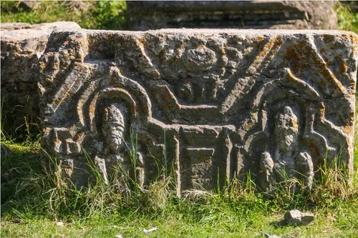

Fig. 2. Martand Sun temple main entrance gateway
It is surprising how these huge stones were piled one upon the other to a great height with such accuracy. The
central building is the most imposing structure and above all has as the temples in Kashmir possess in addition to
the cella or sanctuary, a nave 18 feet square. The sanctuary alone is left entirely bare, the two other compartments
being lined with rich paneling’s and sculptured niches, it has been conjectured that the roof was of pyramidal form
and that the entrance chamber and wings were similarly carved. There would thus have been four distinct pyramids
of which that over the inner chamber must have been the loftiest, the height of its peak above the ground being
about 75 feet.
The temple is 60 feet long and 38 feet wide, its height, when complete must have been 75 feet, the courtyard that
surrounds and encloses the temple, is a more remarkable object than the temple itself. Its internal dimensions are
220 by 142 feet. On each face is a central cella, larger and higher than the colonnade in which it is placed. The
height is 30 feet and the pillars on each side are 9 feet high- not haughty but they have a Grecian aspect which is
interesting. (See Fig.3)
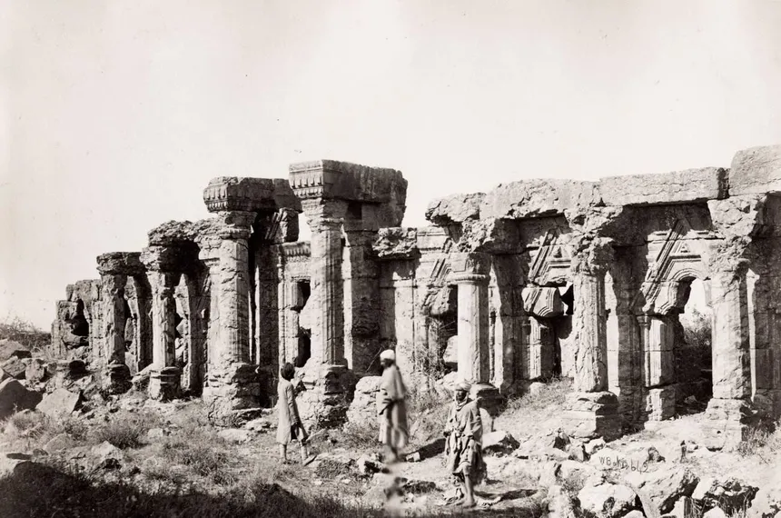
IJNRD2301283 International Journal of Novel Research and Development (www.ijnrd.org) c642© 2023 IJNRD | Volu.me 8, Issue 1 January 2023 | ISSN: 2456-4184 | IJNRD.ORG
Fig.3. Collanade and enclosed walls of Martand Sun Temple
In accordance with Hindu Temple architecture, the primary entrance to the temple is situated in the western side of
the quadrangle and is the same width as the temple itself, creating grandeur. The entrance is highly reflective of the
temple as a whole due to its elaborate decoration and allusion to the deities worshipped inside the complex. It is
thought that the whole of the interior of the quadrangle was originally filled with water to a level up to one foot of
the base of the columns and that access to the temple was gained by a raised pathway of slabs supported on solid
blocks at short intervals which connected the gateways flight of steps with that leading to the temple. The same
kind of pathway expanded right across of quadrangle from one side doorway to the other. A constant supply of
fresh water was kept up through a canal front the river Liddar, which was conducted along the side of the mountain
for the service of the village close through.
Bates says that the interior must have been as imposing as the exterior. On ascending the flight of steps now
covered by the ruins, the votary of the sun entered a highly decorated chamber with a door-way on each side
covered by a pediment with a trefoil-headed niche containing a bust of the Hindu harmony. On the flanks of the
main entrance as well as those of the side doorways were trefoil niches, each of which held a deity. The interior
decorations of the roof can only be conjecturally determined, as there do not appear to be any ornamented stones
that could, with certainty, to assign to it. (See Fig. 4)
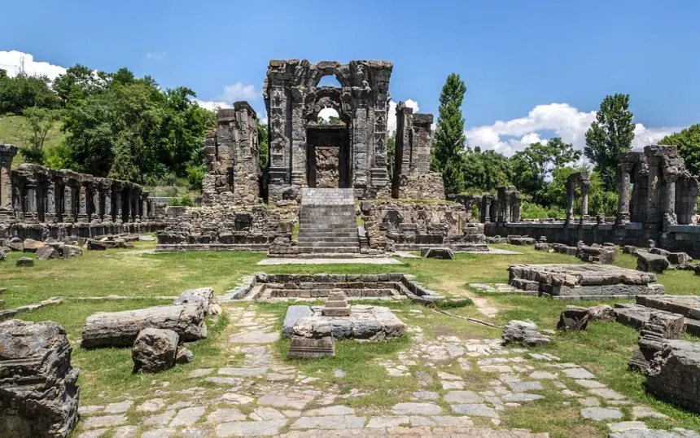
Fig.4 Plan of Martand Sun Temple
Cunningham thinks that the erection of this sun temple was suggested by the glorious sunny prospect which its
position commands. He remarks:
IJNRD2301283 International Journal of Novel Research and Development (www.ijnrd.org) c643© 2023 IJNRD | Volu.me 8, Issue 1 January 2023 | ISSN: 2456-4184 | IJNRD.ORG
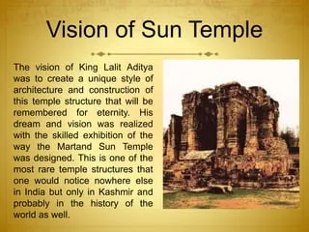
“….It overlooks the finest view in Kashmir, and perhaps in the known world beneath it lies the ‘Paradise of the East’, with its sacred
streams and glens, its orchards and green fields, surrounded on all sides by vast snowy mountains whose lofty peaks seem to smile upon
the beautiful valley below. The vast extent of the scene makes it inspirational, for this wonderful view of Kashmir is no nice-looking gaze
in a half mile glen, but the full display of a valley 30 miles in breadth and 84 miles in length, the whole of which lies beneath the can of the
wonderful Maitand.”
What is most impressive in Martand is the apparently over whelming size- to some degree an optic illusion- and the
complete synchronization of the buildings and of all their decorations and figure sculptures. As we have already
seen they represent the conclusion of a jong development from the simple start depicted by the temples of
Sankarcharya and Pravaresa, through the Parihasapura stupas and temples to the very zenith of Martand.
On the other hand, records Dr. Goetz, ‘Martand stands not quite isolated. It has a smaller counterpart in the plains,
the temple of Malot in the salt range. Malot raises the problems of the Martand temple even more acutely. For it has
a façade of purely Roman- Corinthain half-pillars enclosing trifoliated archways crowned by a set of high sikharas.
If the first has already been proved characteristic for Lalitaditya’s reign, the second was possible only in a time of
the closest contact with Bihar and Bengal- i.e when the king of Gauda had become Lalitaditya’s vassal and
prisoner. Martand has also quite a following of temples of the same layout and construction, through of simple
execution, as for example Wangath and Buniar, which must belong to the same period.

Conclusion
The Martand Sun Temple is highly revered as one of the most inspiring and memorable masterpiece that was
erected during the reign of King Lalitaditya who ruled this region during the ancient era. He ordered the
construction of this spacious and spectacular Martand Sun Temple in Kashmir in honor and dedication to the Sun
God, also referred to as Surya. The King belonged to the Surya dynasty period, and was a Kshatriya, considered to
be a highly authoritative figure, yet considerate and gentle leader to his people, during those times. It was during his
era when the Sun, Moon and Holy entities were greatly worshipped and believed to possess spiritual and
supernatural powers. Built to represent this Solar or Surya Dynasty, King had the Martand Temple built to
commemorate Bhaskar, known then as the Sun God. The Ancient Temple Architecture of Kashmir undoubtedly
bears Greek influence. This influence is starkly visible in the use of stone pillars, columns, trefoil doorways,
ornamental fritters, geometrical designs especially the rectangle and triangles, image of gods carved on stones and pediments. Kashmir stone architects made some amendments to suit harsh winters. This influence is clearly visible in Martand Awantipora Stone temple architecture.
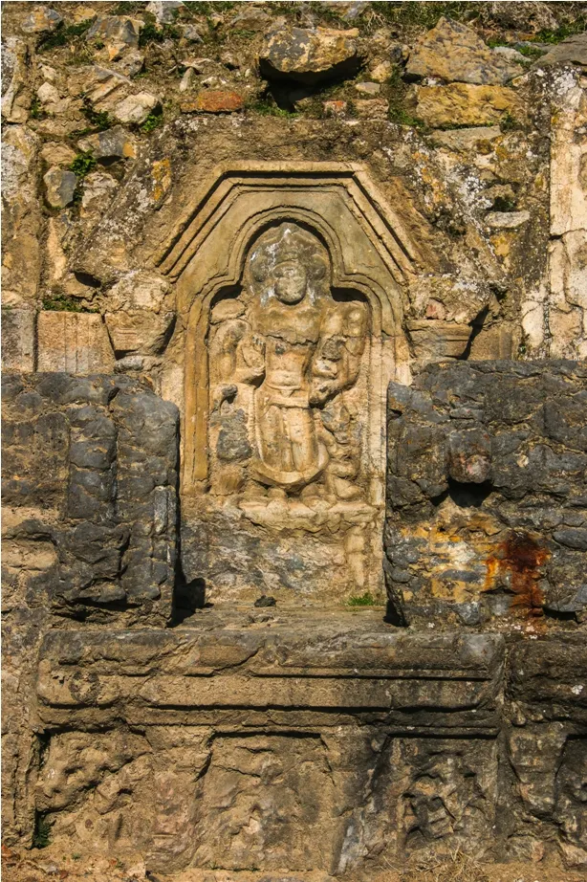
References
Agrawal, R. C. 1998. Kashmir and its monumental Glory. New Delhi: Aryan Books International.
Bamzai, P. N. K. 1994. Cultural and political History of Kashmir. New Delhi: M.D. Publications Pvt. Ltd.
Banerjee, S. C. R. C. Majumdar. 1965. Cultural Heritage of Kashmir. Calcutta: Sanskrit Pustak.
IJNRD2301283 International Journal of Novel Research and Development (www.ijnrd.org) c644© 2023 IJNRD | Volu.me 8, Issue 1 January 2023 | ISSN: 2456-4184 | IJNRD.ORG
Basham, A. L. 1948. Harṣa of Kashmir and the Iconoclast Ascetics. Bulletin of the School of Oriental and
African Studies 12. pp.688-691.
Brown, P. 1942. Indian Architecture: Buddhist and Hindu Period. Bombay: Tobey Press.
Cole. H. H. 1869. Illustration of Ancient buildings in Kashmir. London: W. H. Allen and Co.
Cunningham, A. 1848. An essay on the Aryan order of Architecture as exhibited in the temples in the
temples of Kashmir. JASB 17. pp. 21-327.
Fergusson, J. 1910. History of Indian and Eastern Architecture. Delhi: D. K. Publishers.
Fisher, R. E. 1989. Stone Temples. in Pratapaditya Pal (ed.). Art and Architecture of ancient Kashmir.
Bombay: Marg Publications.
Goetz, H. 1969. Studies in the History and Art of Kashmir and the Indian Himalaya Wiesbaden - Germany:
Harrassowitz.
Kak. R. C. 2000. Ancient Monuments of Kashmir. New Delhi: Aryan Books International.
Mitra, D. 1977. Pandrethan, Avantipur and Martand. New Delhi: Archaeological Survey of India.
Paul, P. G. 1986. Early Sculptures of Kashmir. Unpublished PhD Thesis. Leiden: University of Leiden.
Ray, S. C. 1970. Early history and culture of Kashmir with a foreword by Sardar K. M. Panikkar. New
Delhi: Munshiram Manoharlal.
Sahani, D. R. (1915-16). Pre- Muhammadan Monuments of Kashmir. Annual report 1915-1916. New Delhi:
Archaeological Survey of India.
Stein, M. A. 1900. Kalhana’s Rajatarangni. Vol. 1. Westminster: Archibald Constable and Company Ltd.

Source - Mehbooba Mufti के गढ़ अनंतनाग में Saurabh Dwivedi को Martand Sun Temple में क्या देख आया गुस्सा?

Documentary: The Lost Grandeur of Kashmir’s Martand Sun Temple

Chapter 1: The Marvel of Lalitaditya’s Architecture
- Historical Significance: Built during the 8th century (approximately 724–761 CE) by King Lalitaditya Muktapida of the Karkota dynasty, the Martand Sun Temple stands as a premier example of classical Kashmiri temple architecture and stone craftsmanship [01:10].
- Layout & Structure: The grand temple complex features a central courtyard containing a massive rectangular sanctum (garbhagriha), an assembly hall (mandapa), and flanking chambers [01:25].
- Artistic Details: Carved using solid Devri stones, the temple’s gateway and walls showcase intricate reliefs of river goddesses Ganga and Yamuna, Lord Vishnu, pairs of swans (hansa), celestial figures, and an iconic depiction of the Sun God (Martand) mounted on a chariot [01:39].

Chapter 2: Insights from the Grounds of Anantnag
- Setting the Scene: During ground coverage of the Lok Sabha elections in the high-profile Anantnag constituency, journalist Saurabh Dwivedi visits the heritage site situated atop a plateau [02:06].
- Local Identity & Names: Local resident and guide Zahoor Ahmad Khan shares historical and cultural details about the area and the village known variously as Ranbeerpora and Martand [03:10].
- Ancient Inscriptions & Sculptures: The ruins hold traces of ancient Sharda script, along with elaborate carvings etched into nearly every surviving stone column and lintel across the temple premises [00:08].

Chapter 3: Devastation, Memory, and Decay
- The Fall of the Colossus: The complex suffered destruction during historical invasions under ruler Sikandar Shah Miri, along with centuries of weathering, leaving behind colossal standing colonnades and fragmented stone deities [00:13].
- The Pain of Neglect: The exploration highlights the sheer contrast between the sophisticated civilizational heritage built 1,400 years ago for astronomy and spirituality, and its present-day ruined state needing active conservation [02:43].

Chapter 4: Modern Realities and Preservation Call
- Ground Observations in the Valley: Beyond electoral politics, the ground situation in Kashmir shows noticeable changes in law and order, connectivity, and development infrastructure [34:56].
- Appeal for Restoration: The journey concludes with an appeal to the Archaeological Survey of India (ASI) and the local administration to step up preservation, restoration, and tourism efforts so future generations can witness the remnants of this architectural wonder [35:50].
- Watch Full Video: Martand Sun Temple Exploration – The Lallantop

Frequently asked questions
General & Historical Background
Where is the Martand Sun Temple located?
The temple sits on an elevated plateau overlooking the Kashmir Valley in Mattan, near the city of Anantnag in Jammu & Kashmir (roughly 64 km south of Srinagar).
Who built the Martand Sun Temple and when?
It was commissioned in the 8th century CE (circa 725–756 CE) by King Lalitaditya Muktapida, the most renowned emperor of Kashmir's Karkota Dynasty.
To whom is the temple dedicated?
The principal deity is Surya, the Sun God (Martand is a Sanskrit name for the Sun). The complex also contains carvings of Vishnu, Shiva, and the river goddesses Ganga and Yamuna.

Architecture & Engineering
What architectural style does the temple follow?
It is a classic masterpiece of Kashmiri temple architecture, blending indigenous Kashmiri design with Gandharan, Gupta, Roman, and Byzantine influences.
What are the key architectural features?
- Peristyle Colonnade: A grand courtyard measuring approximately 220 × 142 feet, bordered by 84 fluted columns and smaller shrines.
- Central Sanctuary: A central shrine featuring a garbhagriha (sanctum sanctorum), antarala (antechamber), and mandapa (hall).
- Astronomical Alignment: Oriented so that early morning sunlight directly illuminated the sanctum.
- Materials Used: Massive, precisely carved local grey limestone blocks (Devri stone) joined without mortar.

Destruction & Modern Status
When and how was the temple destroyed?
Historical accounts, including the Kashmiri chronicle Rajatarangini (written by Jonaraja), attribute the temple's major demolition in the early 15th century to Sultan Sikandar Shah Miri (often referred to as Sikandar Butshikan). Subsequent regional earthquakes further degraded the standing structures over centuries.
Who manages the site today?
The Martand Sun Temple is a protected Monument of National Importance managed by the Archaeological Survey of India (ASI).
Can tourists visit the site?
Yes. The site is open to visitors daily from sunrise to sunset. It is accessible by road from Srinagar (approx. 1.5 to 2 hours drive via NH 44).

Quick Facts Overview
Attribute | Details
Builder | King Lalitaditya Muktapida (Karkota Dynasty)
Period | 8th Century CE (~1,300 years old)
Deity | Surya (Sun God)
Location | Mattan, Anantnag District, Jammu & Kashmir
Key Significance | Oldest and largest sun temple complex in Kashmir
Pop Culture Appearance | Featured as the backdrop in the Bollywood film Haider (song "Bismil")

